

Subscribe to Category

User manual

Sidney van de Stouwe

2021

# Contents

Contents 1

1. Introduction 4

1.1. History 4

1.2. New Developments 4

1.3. What is in the manual? 4

1.4. Level of experience 4

2. Installation of the plugin 5

2.1. The normal way 5

2.2. Uploading and Install 5

3. Step by Step guide to get started with STC 6

3.1. Step 1 preparation 6

3.2. Step 2 initial settings 6

3.3. Step 3 new and / or updated posts 6

3.4. Step 4 Create Subscription page 6

3.5. Step 5 Create a new post 7

3.6. Step 6 All Done 7

4. Dashboard with STC activated 9

4.1. Settings 9

Notification 12

4.2. Subscribers 12

5. E-Mail Notification Templates 14

5.1. Repetitive section 14

5.2. Available Placeholders 14

5.3. STC Basic E-Mail Template 14

6. Subscriptions 17

6.1. Custom Posts 17

6.2. Categories 17

6.3. Taxonomies 17

6.4. Basic subscription interface 18

6.5. Enhanced subscription interface - Search 19

6.6. Enhanced subscription interface – Individual Notification trigger 19

6.7. Enhanced subscription interface – SMS Notification 20

7. Shortcode and Attributes 22

7.1. STC Attribute settings 22

7.2. Warning for Curly Quotes 22

7.3. Installing STC’s Widget 22

7.4. Placing the shortcode 24

7.5. Attributes 24

8. Miscellaneous Settings 29

8.1. Email Settings 29

8.2. Attribute Settings 29

8.3. Post Filter Query Link 29

8.4. Reschedule time for sending emails 29

8.5. Resend post on update 30

8.6. Stylesheet Settings 31

8.7. On plugin deactivation 31

9. STC Core functionality 32

10. Timer Jobs in WordPress 33

Figure 1 The STC plugin as described in this manual 5

Figure 2 The uploaded plugin ready to install 5

Figure 3 Newly created page shortcode [stc-subscribe] 6

Figure 4 First Subscription 7

Figure 5 Status of the STC checking function 1 post is to be analysed. 7

Figure 6 The unformatted notification e-mail 8

Figure 7 The log also show that the above email was sent. 8

Figure 8 The status of STC in term of checking for e-mail notifications 9

Figure 9 View on STC Settings (partly) 10

Figure 10 Export to Excel in CSV Tab delimited format 10

Figure 11 Import from Excel in CSV Tab delimited format 10

Figure 12 This Excel must be imported in Tab delimited CSV format 11

Figure 13 Two templates generated by STC 12

Figure 14 One subscriber listed subscribed to Categories, Animals and Taxonomies 13

Figure 15 With the Basic E-mail template for one post to the same subscriber 15

Figure 16 With the Basic E-mail template post to the same subscriber 15

Figure 17 Just using a more sophisticated layout 16

Figure 18 Custom Post Selection 17

Figure 19 WordPress Categories name selected 17

Figure 20 Selected Taxonomy Names 17

Figure 21 Basic subscription interface 18

Figure 22 Enhanced Subscribe interface – Search. 19

Figure 23 Enhanced Subscribe interface – Individual notification trigger. 20

Figure 24 Enhanced Subscribe interface – Notification by SMS message 20

Figure 25 Do not use curly quotes in Shortcode 22

Figure 26 Widget dialog with specific title and field to add attributes 23

Figure 27 Example of applying the shortcode and attributes on a WordPress page 24

Figure 28 With attributes: treeview_enabled="true" and treeview_folded="true" 25

Figure 29 With attributes: treeview_enabled="true" and treeview_folded="false" 25

Figure 30 With attribute: treeview_enabled="false" 26

Figure 31 Widget subscription interface with the unsubscribe checkbox hidden. 27

Figure 32 Subscriber determined email notification moment 27

Figure 33 Category "Reizen" selected filters out other posts 28

Figure 34 E-mail notification analysis on Daily basis (12:00) 30

Figure 35 In the red box the block editor STC update interface 30

Figure 36 In the red box the classic editor STC update interface 31

Figure 37 Setting up an external Cronjob at cronjob.org 33

# Introduction

The reason for writing this manual is to explain the use and features of Subscribe to Category (STC) in more detail. This is because the WordPress readme.txt information is not suitable to explain stuff in detail.

## History

Subscribe to Category (STC) is originally developed by Daniel Söderström as a plugin to be loaded into WordPress. Early 2019 Sidney van de Stouwe took over the plugin. This was primarily done out of personal interest to adapt STC to the ongoing developments of WordPress. Today STC not only is up to date with WordPress 5.6 but the plugin is also able to work with use custom posts and custom taxonomies.

## New Developments

The latest developments of Subscribe to Category (STC) are: Introduction of a notification e-mail template with placeholders and sophisticated keyword’s search features on new/updated posts title, content, tags, and taxonomies.

## What is in the manual?

* Installation
* The admin interfaces.
* The users interface.
* Core functionality
* Using the e-mail notification template
* Advance search features
* Linking to Custom Posts
* Linking to Custom Taxonomies

## Level of experience

This manual expects the user to understand the concepts of WordPress. To work with the e-mail notification templates a good level of understanding in HTML 5 styling and layout’s is expected. Especially the (in)compatibility between different email providers is a tricky subject.

# Installation of the plugin

## The normal way

The following [link](https://www.wpbeginner.com/beginners-guide/step-by-step-guide-to-install-a-wordpress-plugin-for-beginners/) describes clearly how to install a plugin. Look for "Subscribe to Category" as name. Follow the steps explained in the beginner’s document.

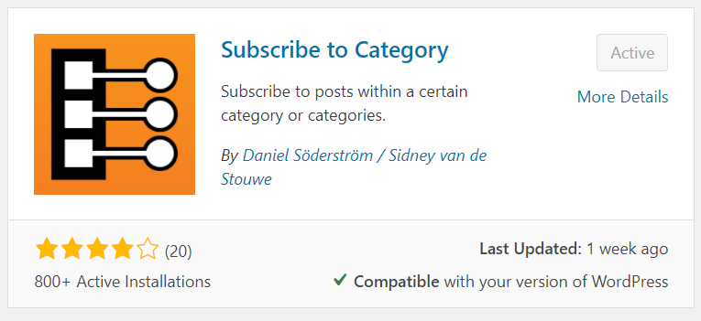

Figure 1 The STC plugin as described in this manual

## Uploading and Install

In some cases, it is of more use to upload a zip file containing the plugin. The [link](https://www.wpbeginner.com/beginners-guide/step-by-step-guide-to-install-a-wordpress-plugin-for-beginners/) describes also this situation.

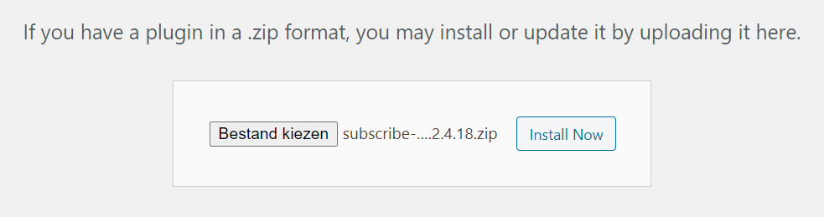

Figure 2 The uploaded plugin ready to install

Plugin developers can install and test a version of the plugin before publishing the updated plugin on WordPress.

# Step by Step guide to get started with STC

In this chapter we take you step by step until the first e-mail notification is sent to the first subscriber. If from your site mails are sent with the ability to inspect the mails sent, you are ready to go. If you do not have this ability it is advised to load a plugin that will give you that ability. Author of this manual uses "WP Mail Log" frequently analysing issues if e-mails send by STC are not received.

## Step 1 preparation

1. Login to your site as administrator
2. Test if your site can send a test mail.
3. Load the STC plugin as described in paragraph 2.1 The normal way

## Step 2 initial settings

1. Go to the dashboard and select STC Subscribe -> Settings
2. Make sure all fields are empty and all checkboxes are unchecked.
3. If your site is using the classic editor, you are ok and then click the "Save Changes" button and continue to number 8
4. If your site is using the block-editor, you must check the block-editor checkbox and then click the "Save Changes" button

## Step 3 new and / or updated posts

1. If subscribers must be notified when a post is updated, you need to check the Resend checkbox.

## Step 4 Create Subscription page

1. Go to the dashboard and create a new page (Page -> Add New). Give the page a title and in the block-editor create a "shortcode block". Then enter the shortcode [stc-subscribe]
2. Publish the page and when the page is viewed the page should look like the figure below

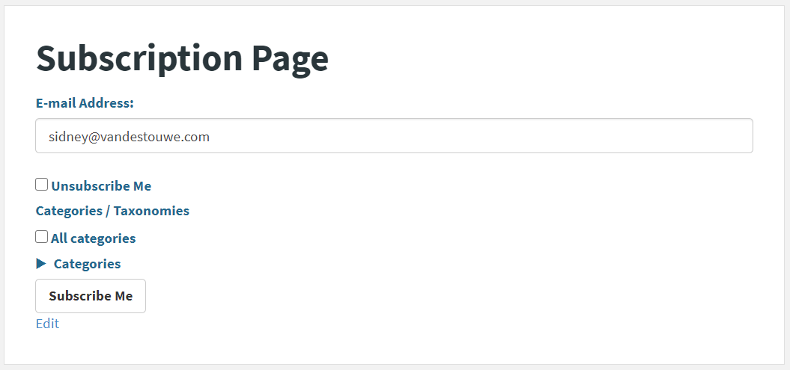

Figure 3 Newly created page shortcode [stc-subscribe]

1. The email address field is now showing your login email address. This is because you are logged in as administrator.
2. Check "All categories" and click button "Subscribe Me" then go to Dashboard -> STC Subscribe -> Subscribers and you should see yourselves listed as subscriber. You are now subscribed to all available categories.

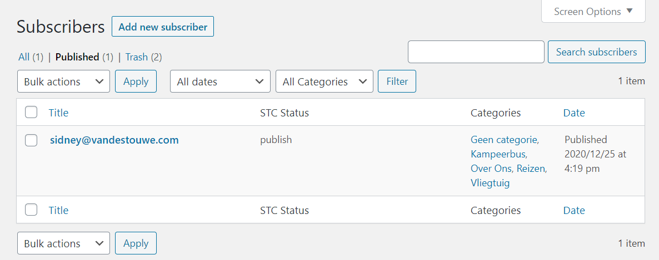

Figure 4 First Subscription

## Step 5 Create a new post

1. Create a new post in whatever way your site is setup, provided the newly created post will become visible when clicking on . Read paragraph 6.1 to connect STC to custom defined posts.
2. Assign one or more categories to the post and thereafter publish your new post immediately.

## Step 6 All Done

1. You should receive an e-mail notification with the next 3600 seconds or sooner depending on when STC is checking is triggered again.
2. Or if you do not want to wait you can trigger STC to start checking now by going to Dashboard STC Subscribe -> Settings and you will see something like in the figure below. It shows that 1 post is to be analyzed and if somebody is subscribed to it a notification will be sent. STC will be triggered up or just after 2020-12-25 22:48.

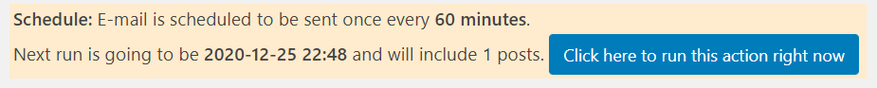

Figure 5 Status of the STC checking function 1 post is to be analysed.

1. Clicking the button will trigger STC to start checking now. If all went ok, you should have received an e-mail as is showed in the figure below.

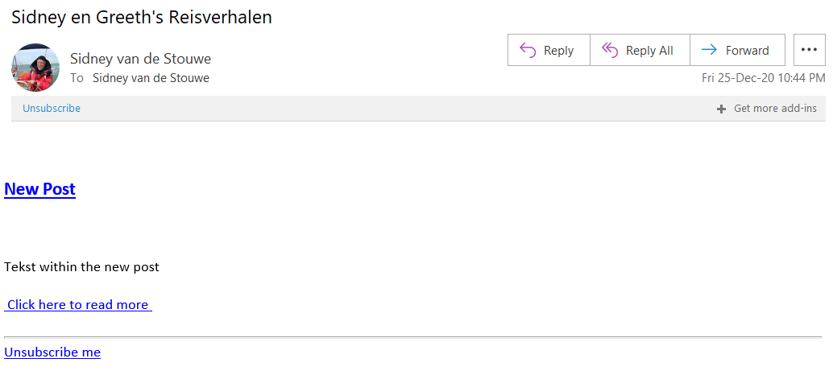

Figure 6 The unformatted notification e-mail

1. If you did not received the e-mail. Check if STC did try to send it by inspecting the e-mail log. In the error column a possible hint is given concerning the problem.

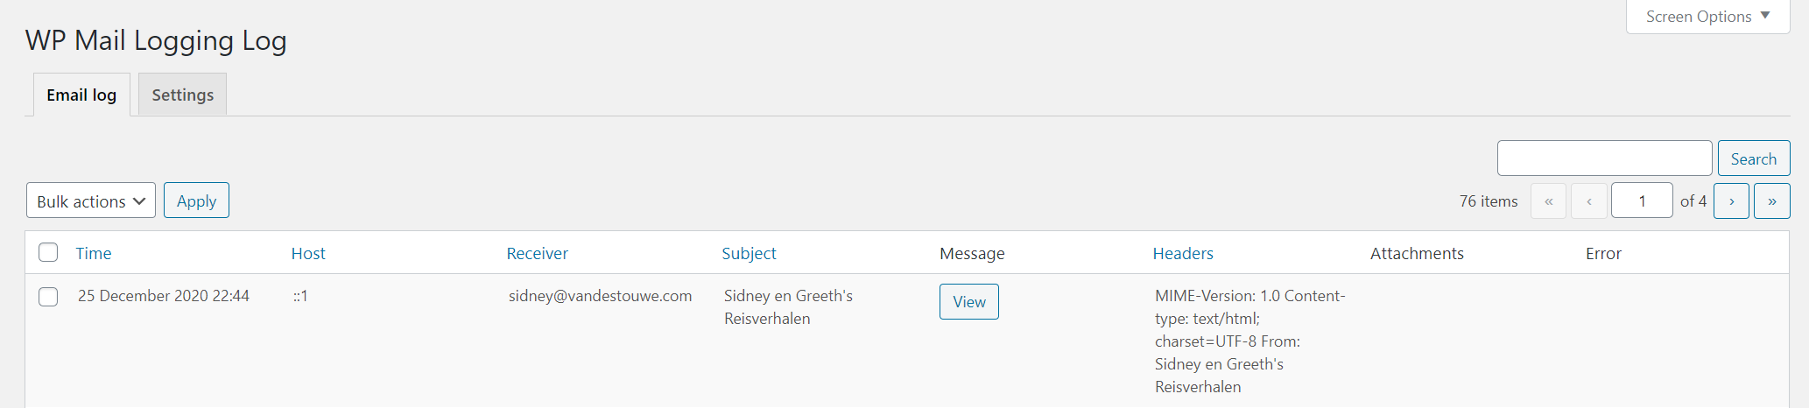

Figure 7 The log also show that the above email was sent.

# Dashboard with STC activated

In the figure below the dashboard is shown with STC’s Subscribe menu unfolded.

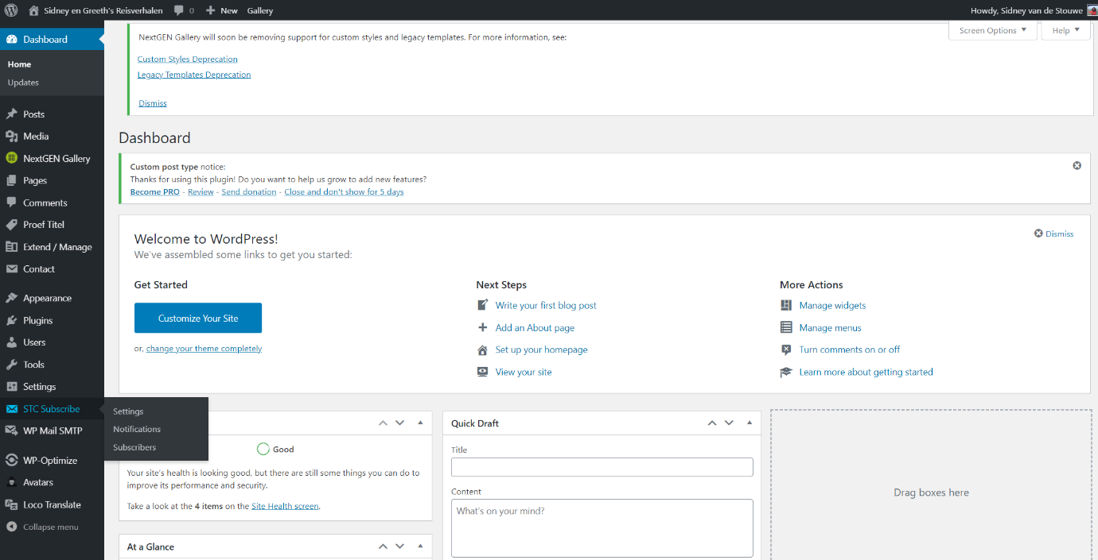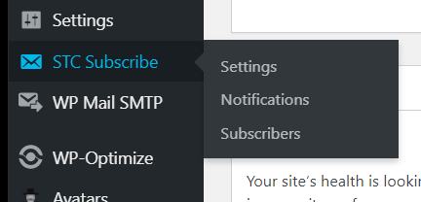

## Settings

The settings page has four sections:

### First section of STC Settings

The first section is the status panel of the background task to check for new and / or updates post. It shows the time for the next subscription check and how many posts have the status "outbox". Clicking the button will immediately run the task.



Figure 8 The status of STC in term of checking for e-mail notifications

### Second section of STC Settings

The second section contains the settings for STC.

1. E-mail settings
2. Custom Post Type Name(s) selection
3. Taxonomy Name(s) selection
4. E-Mail Template selection for notification e-mails
5. Attibute settings
6. Reschedule time for sending e-mails.
7. Resend Post on update
8. Stylesheet (CSS) settings
9. On plugin deactivation

* Item 4 is discussed in chapter 5. E-Mail Notification Templates
* Items 2, 3 are discussed in chapter 6. Subscriptions
* Item 5 is discussed in chapter 7. Shortcode and Attributes
* Items 1, 6, 7, 8, 9 are discussed in chapter 8. Miscellaneous Settings

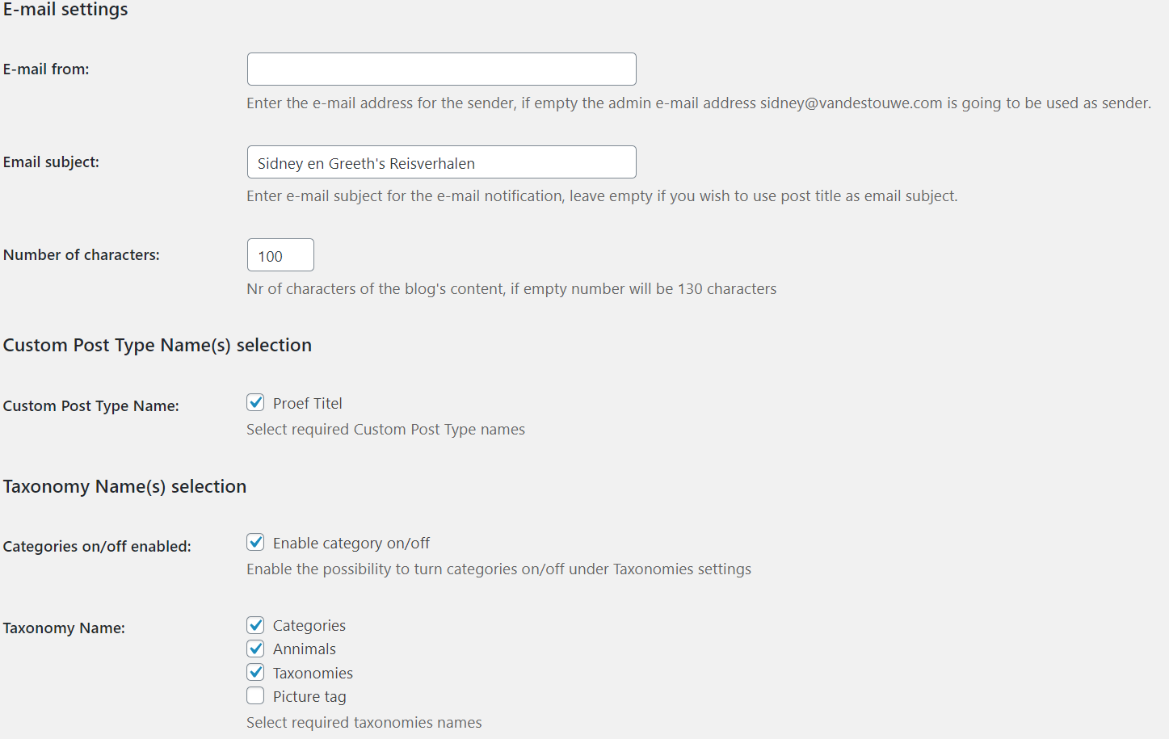

Figure 9 View on STC Settings (partly)

### Third section of STC Settings

The third section contains an export to excel function. This function still needs to be updated with custom taxonomies. Details on the format are explained in the fourth section.

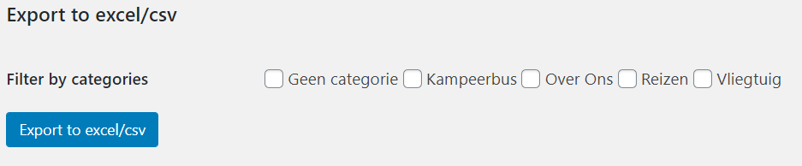

Figure 10 Export to Excel in CSV Tab delimited format

### Fourth section of STC Settings

The fourth and final section contains an import function. This function still needs to be updated with custom taxonomies.

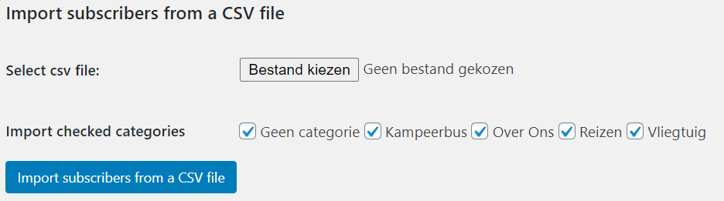

Figure 11 Import from Excel in CSV Tab delimited format

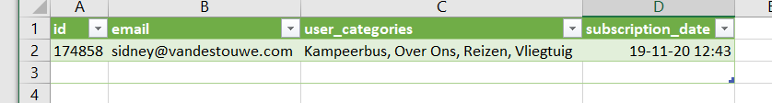

Figure 12 This Excel must be imported in Tab delimited CSV format

**Tab delimited csv format. The red underlined areas are tabs:**id email user_categories subscription_date  
174858 sidney@vandestouwe.com Kampeerbus, Over Ons, Reizen, Vliegtuig 2020-11-19 12:43:22

To import the .csv file into excel follow these steps:

1. Open a blank workbook in Excel.
2. On the Data menu click on From Text/CSV you must choose TAB as delimiter
3. If all looks well, click on Load and you should see the imported data as show in Figure 12
4. Changes can be made, and row deleted or added as much as needed.
5. The id and date column can be 0, STC will create new ids and dates on import.
6. Make sure that the sheet is no longer than the last record in use to avoid empty lines.

To prepare the excel file for import into STC.

1. Save the sheets as a tab delimited text file.
2. Make sure there are no empty lines in the .txt file.
3. Go to the import setting of STC.
4. Choose the tab delimited .txt file for import (set file filter to *.*)
5. On the top line of your window, you should see the import confirmation message.

## Notification

Notifications are factually postings of type ‘notification’ but only available to STC. Each post contains an e-mail layout with placeholders. Both the posts are automatically generated by STC when the post slug is not available in any post state. The moment one of the posts is permanently deleted STC will generate a new one.

Using the templates is discussed in chapter 5. E-Mail Notification Templates

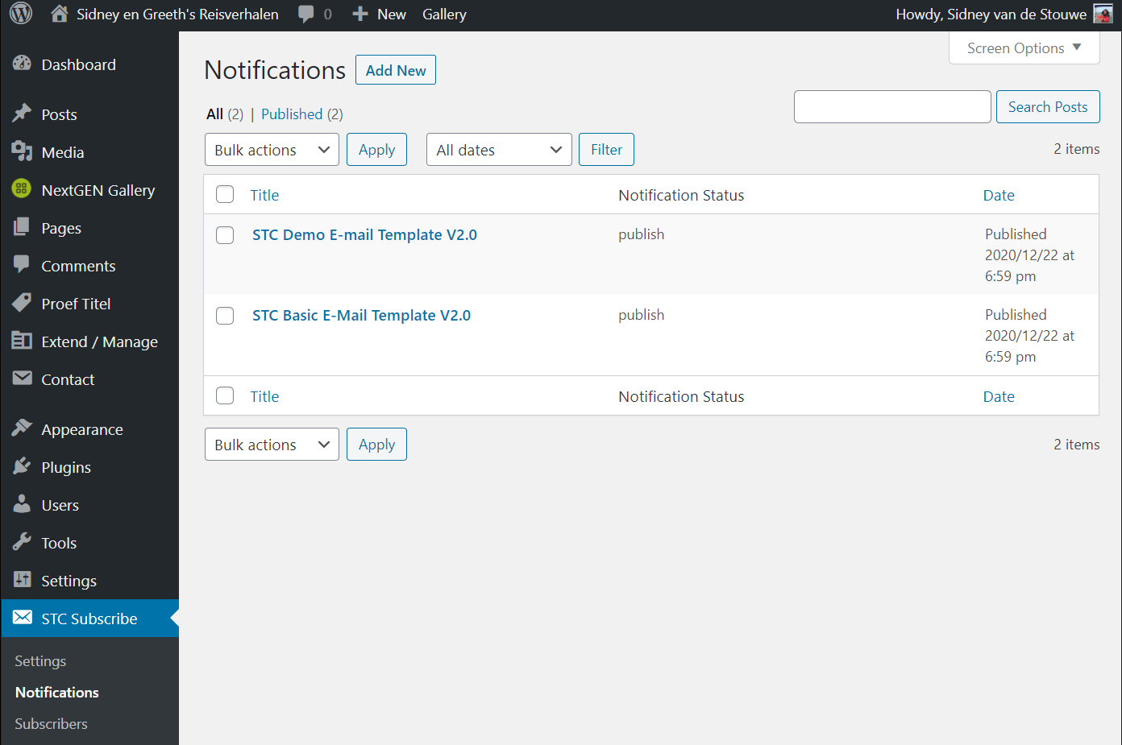

Figure 13 Two templates generated by STC

## Subscribers

Subscribers are factually postings of type ‘stc’ but only available to STC. Each post contains all the relevant data belonging to the subscriber identified by the post title containing the subscribers e-mail address. Subscribers can be generated via the shortcode interface(s) or via edit post. More on subscribers is discussed in chapters 7. Shortcode and Attributes

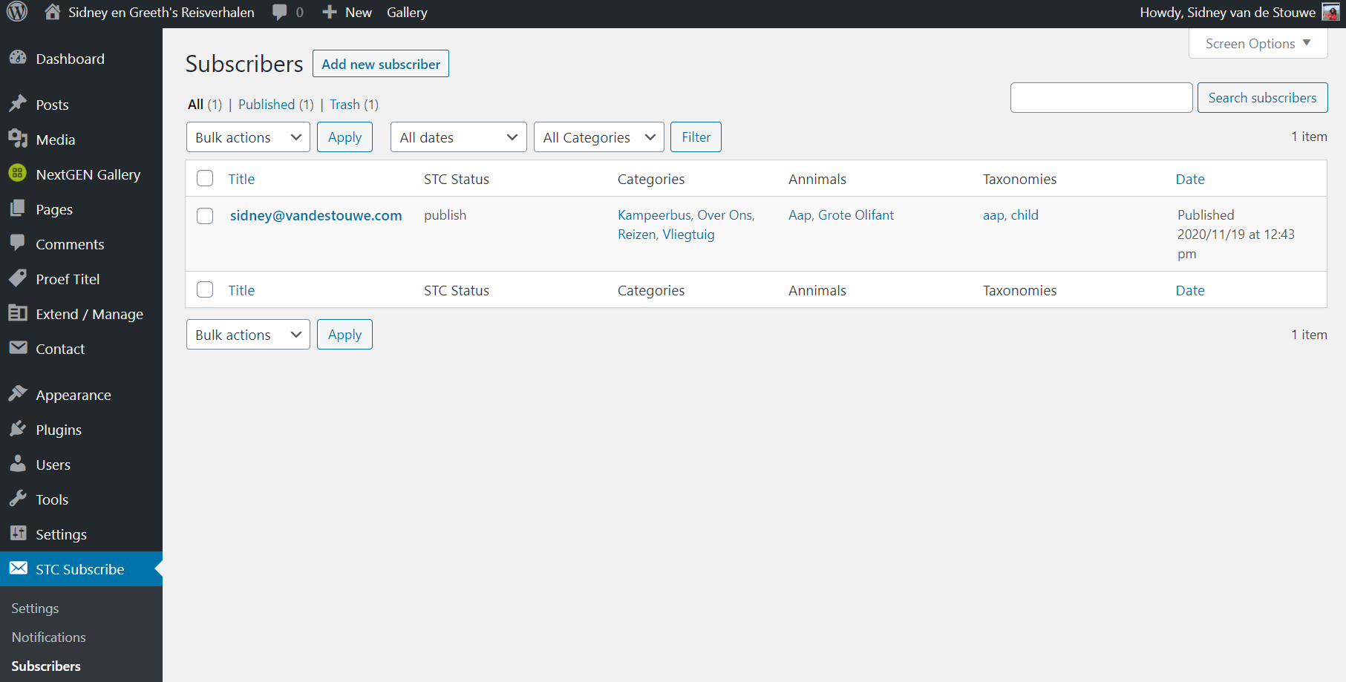

Figure 14 One subscriber listed subscribed to Categories, Animals and Taxonomies

# E-Mail Notification Templates

When using the block editor, the whole layout must be in one HTML block nothing before and after the block. The same applies for the classic editor only pure HTML code is to be used.

For an easy start it is best to permanently delete all notification posts. STC will than automatically setup two new clean post.

## Repetitive section

STC is providing a template to be used when sending e-mail notifications. STC merges multiple notification e-mails into one e-mail containing multiple notifications. Some extra placeholders are introduced acting as repetition markers. STC will repeat anything between the two marker placeholders in the case of multiple notification to subscriber.

## Available Placeholders

|  |  |  |
| --- | --- | --- |
| Mandatory | Format | Description |
| Yes | {{start_content}} | Section repeat starts marks start of post |
| Yes | {{end_content}} | Section repeat stops marks end of post |
|  | {{search_reason}} | Unformatted search result information |
|  | {{blog_title}} | Unformatted blog title |
|  | {{post_title}} | Unformatted post title |
|  | {{post_author}} | Name of the author |
|  | {{post_title_with_perma_link}} | Post title as permalink class= "stc-post-title-a" |
|  | {{post_featured_image}} | Featured Image (Post Thumbnail) of the post |
|  | {{post_featured_image_url}} | URL of the Featured Image (Post Thumbnail) of the post |
|  | {{post_content}} | Post content formatted by post class= "stc-read-more-a" |
|  | {{post_excerpt}} | Excerpt from $post |
|  | {{post_excerpt_with_read_more_link}} | Excerpt from post with read more link |
|  | {{draw_line}} | Horizontal line with class="stc-notify-hr" |
|  | {{unsubscribe}} | Unsubscribe link class="stc-unsubscribe-a" |

## STC Basic E-Mail Template

### HTML code

<style> .stc-notify-hr { width:100%;} .stc-read-more-a { color: #000000} .stc-post-title-a { color: #000000;} .stc-unsubscribe-a { color: #000000;} </style>  
<p>Placeholder for: {{blog_title}}</p>  
<!-- stc: Mandatory command marks start of content -->{{start_content}}  
<!-- stc: Command to draw a line separator -->{{draw_line}}  
<p>Placeholder for the reason why you receive the notification: {{search_reason}}</p>  
<p>Placeholder for: {{post_title}}</p>  
<p>Placeholder for: {{post_title_with_perma_link}}</p>  
<p>Placeholder for: {{post_featured_image}}</p>  
<p>Placeholder for: {{post_content}}</p>  
<p>Placeholder for: {{post_excerpt}}</p>  
<!-- stc: Mandatory command marks end of content -->{{end_content}}  
<!-- stc: Command to draw a line separator -->{{draw_line}}  
<p>Placeholder for: {{unsubscribe}}</p>

### E-mail for one post

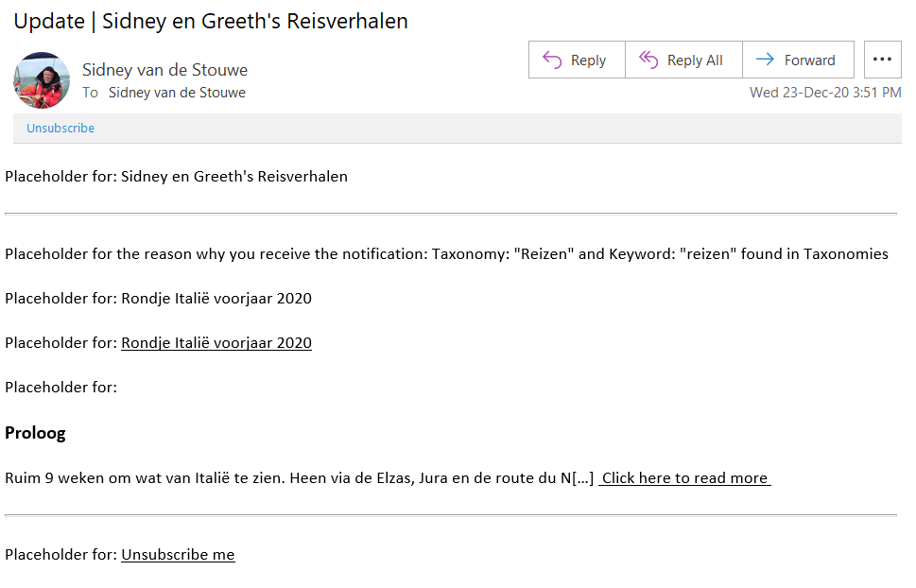

Figure 15 With the Basic E-mail template for one post to the same subscriber

### E-mail for three posts using the same template

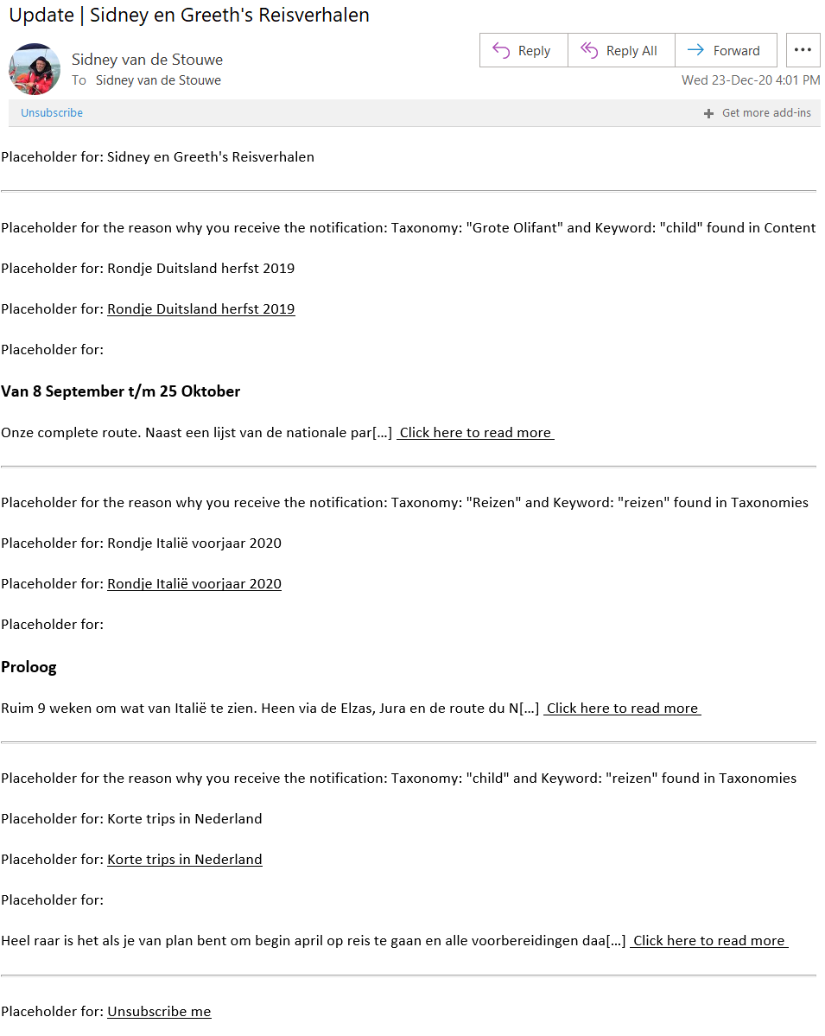

Figure 16 With the Basic E-mail template post to the same subscriber

### E-mail for one post using the Demo E-mail Template

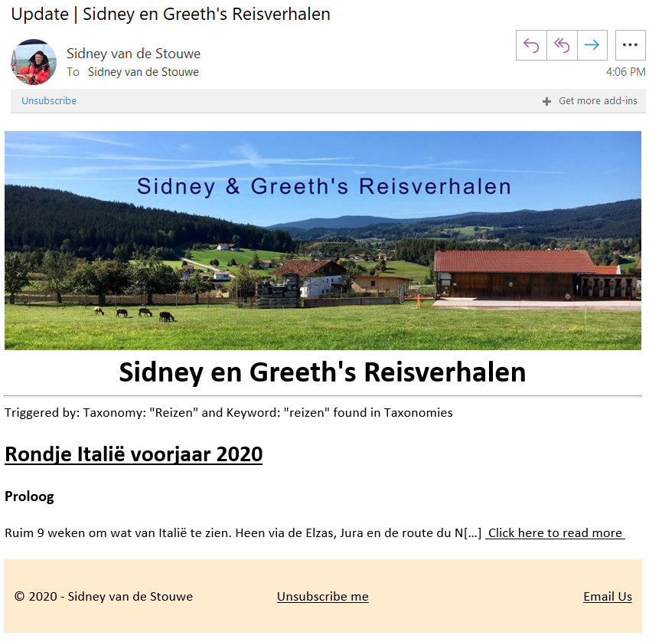

Figure 17 Just using a more sophisticated layout

# Subscriptions

## Custom Posts

STC does not create custom post itself but it can connect to these posts. When checked STC will also look for new and/or updated in the checked custom posts. Only select to custom post that you want the subscriber to subscribe to. When no custom posts are available there will be no boxes to tick.

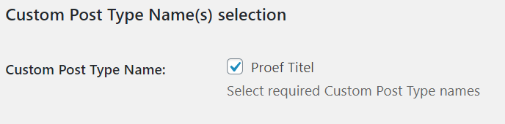

Figure 18 Custom Post Selection

## Categories

STC is connected to WordPress categories. With the introduction of Custom Taxonomies STC handles the WordPress categories as taxonomies. It is for this reason that categories are listed as an available Taxonomy Name.

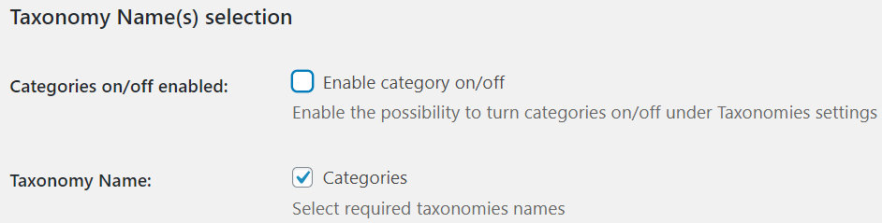

Figure 19 WordPress Categories name selected

## Taxonomies

When custom taxonomies are available to connect to the STC Settings interface shows the available taxonomy names. Only select taxonomies that you want to be available to the subscriber and the by STC selected custom posts.

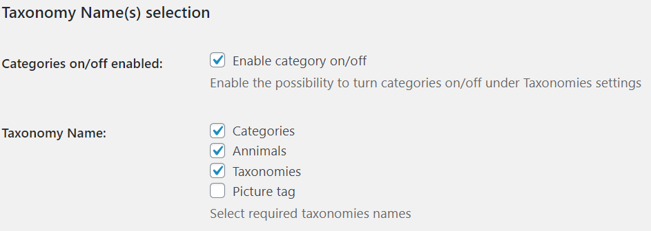

Figure 20 Selected Taxonomy Names

In cases where the WordPress categories must not be available to subscribers it is possible to uncheck the Categories checkbox. *This will only have effect if this is allowed by the Enable category on/off checkbox. In the above figure, one can turn the WordPress categories off.*

## Basic subscription interface

Subscription is possible on the admin level by editing the post or via the subscription user interfaces. The look and feel of the two interfaces are described in detail in chapter 7.

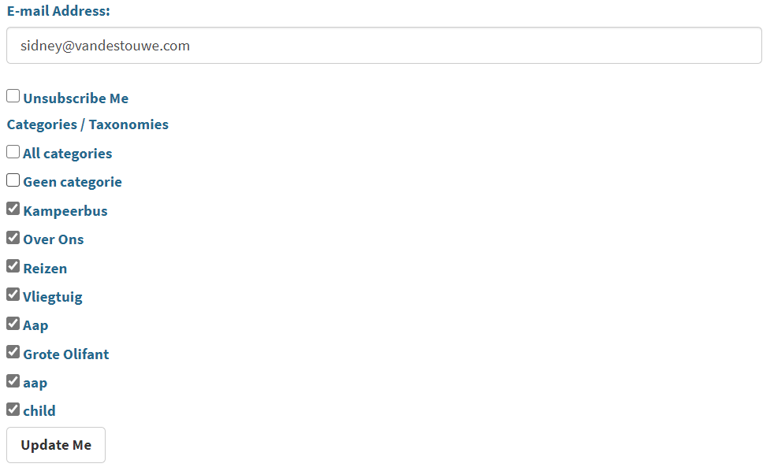

Figure 21 Basic subscription interface

If the email address field is empty it indicates that no user is logged in to the site. Subscriptions can be created but they all will go into the "Approval" state awaiting e-mail confirmation by the given e-mail address. STC will look for a landing page with the slug stcs-confirmation-page. If a placeholder {{stc-notice}} exist on this confirmation page`, STC will replace this with the notice. If no landing page is given with the slug: stcs-confirmation-page STC will create a custom page with minimal information.

If after 24+ hours the confirmation is not activated by the e-mail receiver, the subscription is permanently deleted by STC.

On confirmation by the subscriber STC will look for a landing page with the slug stcs-landing-page. If a placeholder {{stc-notice}} exist on this landing page`, STC will replace this with the notice containing the result of the confirmation. If no landing page is given with the slug: stcs-landing-page STC will create a custom page with minimal information.

### Creating or Updating subscriptions

If the user is logged in to the site than the e-mail field contains the e-mail address of the logged in user.

Depending on the user’s role:

* If user is administrator than user can create and / or change any subscription for any e-mail address. *On submit the current email address is also saved and will be restored when the page is reinitialized.*
* If user is logged in, but not as administrator, then the e-mail address field is locked, and this user can only create or update the subscription of the e-mail address as given in the e-mail address field.

## Enhanced subscription interface - Search

The enhanced subscription interface is only available when the STC shortcode has an attribute called: [stc-subscribe keyword_search="on"][1]. By adding this attribute, the subscription interface is enhanced with keyword search features as shown in the red box below.

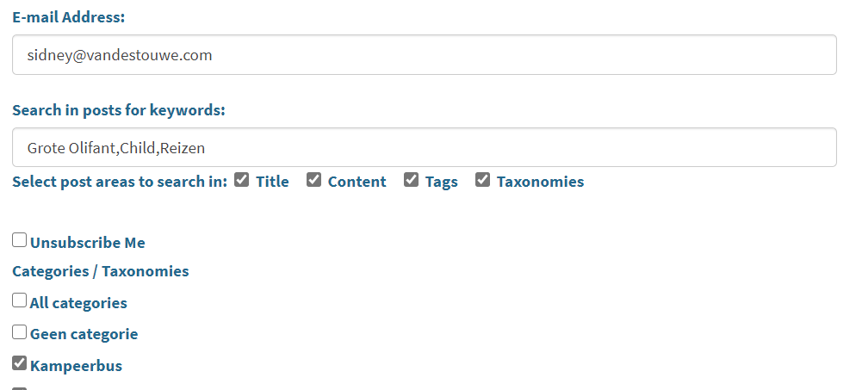

Figure 22 Enhanced Subscribe interface – Search.

### Using Keywords

* Keywords are comma delimited.
* All characters between commas are part of a keyword spaces include. "Grote Olifant" is one keyword.

### Search areas

* On checked Title: keywords are search for in the post titles.
* On checked Content: keywords are search for in the post contents.
* On checked Tags: keywords are search for in the post tags.
* On checked Taxonomies: keywords are search for to the assigned categories/taxonomies of the posts.
* The search for keywords is stopped immediately after the first keyword is found.
* The search order is: Title, Content, Tags, Taxonomies.
* Unchecked areas are excluded from the search for keywords.

### When an e-mail notification is sent

1. With no keywords assigned STC will check if one of the assigned taxonomies to the post are also assigned by the subscriber.
2. With no taxonomies assigned by the subscriber STC will check the keywords. STC will search for the keywords in the post.
3. With taxonomies and keywords assigned by the subscriber STC will check if the assigned taxonomies of the post are also assigned by the subscriber and will search for the keywords in the post.
4. When none of the above three situations is true for a particular subscriber this subscriber will not receive an e-mail notification.

## Enhanced subscription interface – Individual Notification trigger

The enhanced subscription interface is only available when the STC shortcode has an attribute called: [stc-subscribe subscriber_notification="true"]. By adding this attribute, the subscription interface is enhanced with trigger moment checkboxes as shown in the red box below.

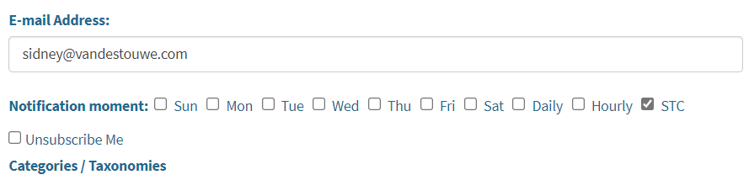

Figure 23 Enhanced Subscribe interface – Individual notification trigger.

Normally STC sends notification by the STC admin settings. With the help of this attribute, it is possible that’s each individual subscriber can decide when the notifications are send. Default is "STC" this means that the admin settings are followed. All other settings are per subscriber unique. The following combinations are possible:

* one out of: Daily or Hourly or STC.
* one or more of the weekdays.

## Enhanced subscription interface – SMS Notification

The enhanced subscription interface is only available when the STC shortcode has an attribute called: [stc-subscribe mobile_phone="on"]. By adding this attribute, the subscription interface is enhanced with a mobile number field as shown in the red box below.

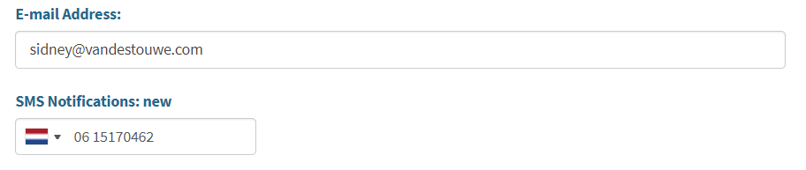

Figure 24 Enhanced Subscribe interface – Notification by SMS message

*This will only work if your site has a paid subscription with the TextMagic organization. At this point in time only one SMS provider (TextMagic) is implemented. Please do not select this attribute if you do not have a key and login name for using the TextMagic API. However, if you are interested contact* [*sidney@vandestouwe.com*](mailto:sidney@vandestouwe.com) *to discuss the possibilities.*

*If any PHP API of any SMS provider has functions for:*

1. *STC can send a multipage SMS to a receiver,*
2. *Provider sends a delivery notification via REST API / post / json callback.*
3. *On receiver sending a SMS to STC, Provider sends message via a callback via REST API /post / json.*

*It will be possible to integrate STC with the provider's PHP API.*

### Mobile number - Local versus International

It is possible to give the number in international or national format. STC will take care of checking the number based on the selected flag and/or the number typed. Directly under the mobile number field a message is displayed when STC has concerns regarding the number.

### SMS Notification: statuses

* New: A subscription SMS is sent to the given mobile number
* Join pending: The subscription SMS is delivered on the mobile device.
* Joined: The mobile device has responded with a "Join" reply to STC
* Stopped: The mobile device requested to no longer receive SMS notifications by replying "Stop" to STC.

# Shortcode and Attributes

## STC Attribute settings

In the STC settings the options under the section "Attribute settings" play a role together with the attributes in the Shortcode.

1. Enable ***hide_unsubscribe*** attribute use. This unlocks the hide_unsubscribe Shortcode attribute.
2. Enable ***enable_keyword_search*** attribute use. This unlocks the enable_keyword_search Shortcode attribute.
3. Enable ***taxonomy_hierarchy*** attribute. This enables showing the reason why an email notification was sent including the hierarchy of the term.

The Shortcode of STC [stc-subscribe] can be placed in a post or on a page. Implicit the Shortcode is also active when placing the STC widget in one of the widget areas. Each Shortcode or implementation of STC’s widget has a unique set of attributes.

## Warning for Curly Quotes

The problem is that the WordPress Shortcode processor does NOT like curly quotes. If you use curly quotes in a shortcode attribute such as [stc-subscribe treeview_enabled="false"] and those quotes are “curly”, WordPress treats the quotes as a plain-old alphabetic character. This will break the Shortcode function completely.

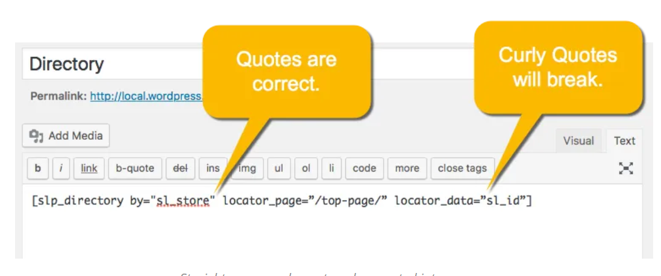

Figure 25 Do not use curly quotes in Shortcode

Make sure you re-type each quote manually. Typing the " in your blog instead of copy-and-paste will ensure you are getting "straight quotes" in your Shortcode attributes.

## Installing STC’s Widget

STC’s Widget is also available and can be activated via the admin interface for Widgets. Drag the "Subscribe to Category" widget to the sidebar or one of the footers. Open the Widget to enter attributes as can be seen in the figure below.

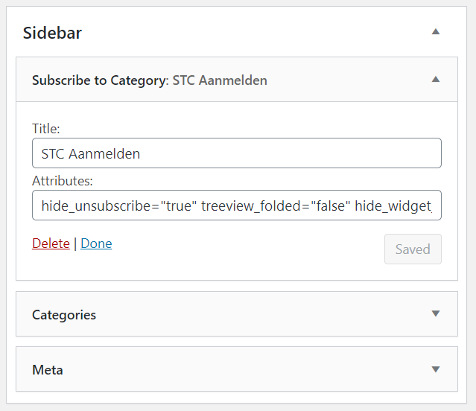

Figure 26 Widget dialog with specific title and field to add attributes

## Placing the shortcode

The shortcode [stc-subscribe] can be placed on pages or post. WordPress executes the shortcode by calling STC’s shortcode function.

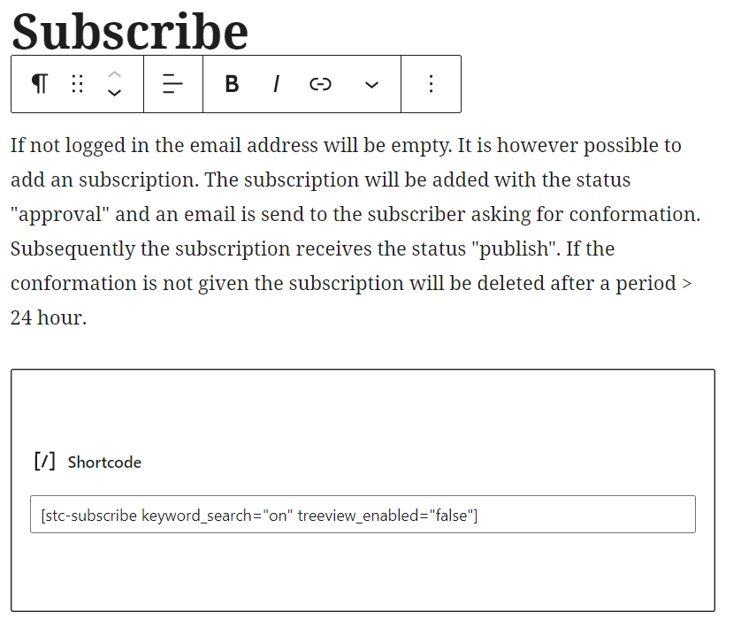

Figure 27 Example of applying the shortcode and attributes on a WordPress page

## Attributes

### Attributes Table

|  |  |  |
| --- | --- | --- |
| Attribute | Description | Default |
| hide_unsubscribe="true" | Hide unsubscribe checkbox on the page[2] | false |
| hide_widget_on_page="xxx" | Hides the STC Widget if active page = xxx | none |
| subscriber_notification="true" | Notification moment per subscriber | false |
| mobile_phone="on" | Notification via SMS | false |
| treeview_folded="false" | Start with cat/tax unfolded | true |
| treeview_enabled="false" | Disable cat/tax as tree view | true |
| keyword_search="on" | Enables the search for keywords[3] | off |
| category_in="name1, name2" | Include listed cat/tax names | all cat/tax |
| category_not_in="name1, name 2" | Exclude listed cat/tax names | none |
| category_id_in="id1, id2" | Include listed cat/tax id’s | all cat/tax |
| category_id_not_in="id1, id2" | Exclude listed cat/tax id’s | none |
| smart_filter_usage="true" | Use terms in Query Filter as subscription | false |

### Categories / Taxonomies in Tree view mode

Category / Taxonomy filtering is tricky in tree view mode. This is because you cannot filter in a part of a tree. It is for this reason that the Tree view enabled mode is ignored to avoid confusion and to keep in line with STC updates from older versions.

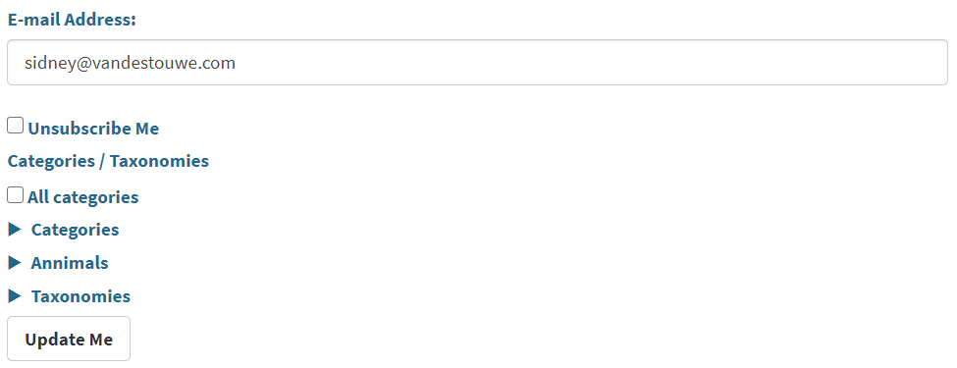

Figure 28 With attributes: treeview_enabled="true" and treeview_folded="true"

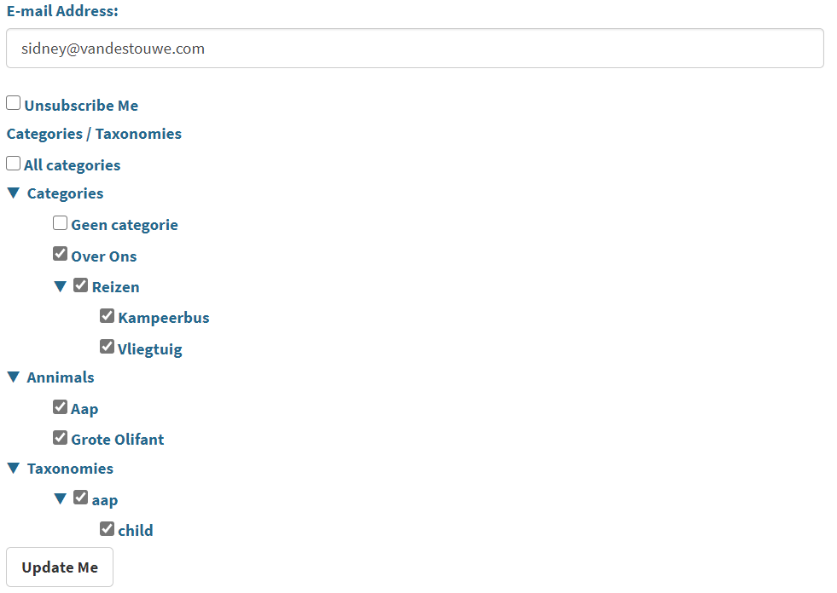

Figure 29 With attributes: treeview_enabled="true" and treeview_folded="false"

### Categories / Taxonomies in List mode

Categories / Taxonomies listed in the same order as they would have been listed as tree view. This list can be quite lengthy and is only recommended for a view Categories / Taxonomies.

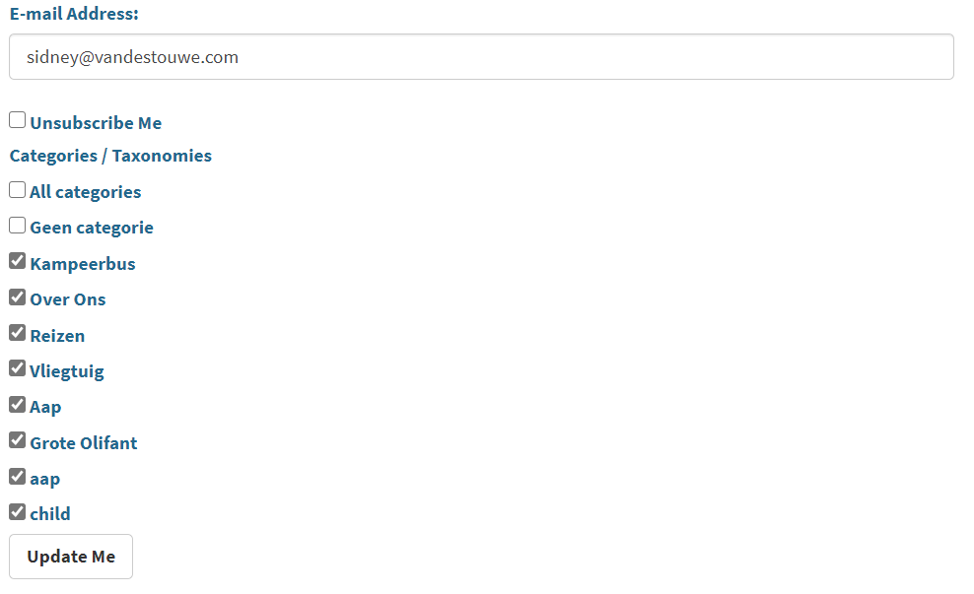

Figure 30 With attribute: treeview_enabled="false"

### Filtering Categories / Taxonomies

When one of the categories in or not in attributes is used Tree View will be disabled and the List View will automatically be activated.

Categories can be filtered in our out depending on the activated attributed. Either the name or the id of the category can be used again depending on the activated attribute.

### Taxonomies are notified with hierarchy.

When this attribute used is in the taxonomy_hierarchy="on" state it will give the subscriber a possibility to decide how notification reason are shown in the notification e-mail. More detail is found in paragraph **Error! Reference source not found.**

### Keyword Search

This attribute unhides the fields and checkboxes necessary for the search to keywords in new or updates post. The subscription interface with the attribute keyword_search="on" is found in paragraph 6.5

### Hide Unsubscribe

This attribute hides the Unsubscribe checkbox. The subscription interface with the attribute hide_unsubscribe="true" is found in the figure below.

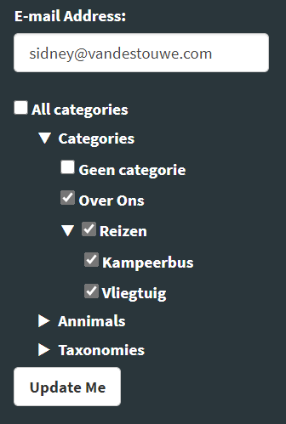

Figure 31 Widget subscription interface with the unsubscribe checkbox hidden.

### Email Notification Moment per subscriber

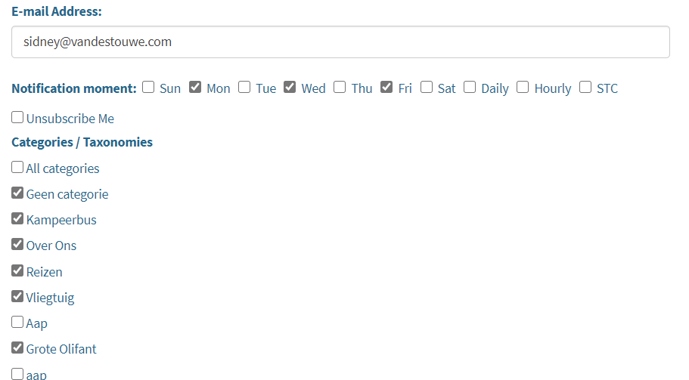

Figure 32 Subscriber determined email notification moment

With the attribute subscriber_notification="true" it is possible to determine the e-mail notification moment per individual subscriber. Choices are Sun..Sat or Daily or Hourly or STC. In the image above the subscriber [sidney@vandestouwe.com](mailto:sidney@vandestouwe.com) will receive email notifications clustered on Monday, Wednesday and Friday. Choosing STC means that email notifications will be sent determined by the settings of STC. The exact times, for daily and hourly are set by the STC settings for the timer and daily.

### Hide STC Widget on certain pages

In the case the active page is showing the subscriber interface and in the STC Widget is also on the sidebar or footer areas it is better to hide the widget. The attribute used for that reason is: hide_widget_on_page="xxx" where xxx stands for the Title name of the active page.

### Use Smart Filter Terms as subscription

The attribute smart_filter_usage="true" can be used as subscription set to insert new or update existing subscribers. If true, all Taxonomies in the STC widget or STC Shortcode are hidden. STC, when clicked for subscribe or update, will take the contents of the last used Posts Filter instead.

STC Widget

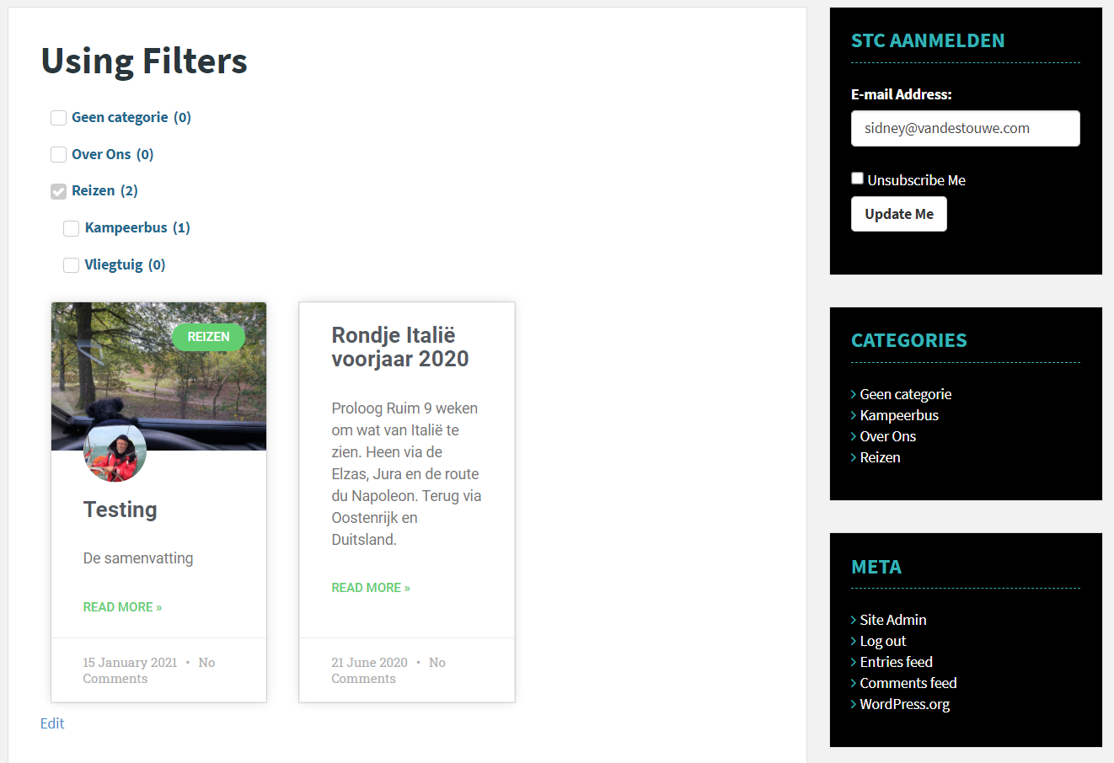

Edit Post Elementor Pro Widget

Jet Smart Checkbox Filter

Figure 33 Category "Reizen" selected filters out other posts

Clicking on "Update Me" results in an update of the subscription of the subscriber [sidney@vandestouwe.com](mailto:sidney@vandestouwe.com) to "Reizen"

Steps you will need the have set, done or installed:

* Elementor Pro
* Jet Smart Filers
* Set the name of the filter query on the STC setings page
* Add smart_filter_usage="true" attribute to the STC shortcode or widget
* Create a page with the mandatory slug "stcs-filter-posts-page"
* Create a Smart Filter
* Add and set "Edit Checkboxes Filer" widget to the page.
* Add and set "Edit Posts" widget to the page.
* Add and set the STC Widget to the page

# Miscellaneous Settings

## Email Settings

**Field E-Mail from:**When left blank the admin e-amil address will be used. Otherwise enter an e-mail address. This address will be used as the from: for sending STC e-mails.

**Field E-Mail subject:**When left blank the post title of the will be used as subject for sending STC e-mails.

**Field number of characters:**The number of characters taken from the post content (first abstracted by WordPress "the_content" filter).

## Attribute Settings

These settings control the usage of a specific attribute. They are introduced to allow / ignore the usage of the attribute on STC’s shortcodes.

**Checkbox Unsubscribe:**When this checkbox is checked the unsubscribe possibility can be hidden from the users. Provided the hide unsubscribe attribute in the shortcode is set to true.

**Checkbox Keyword search:**When this checkbox is checked the search for keywords functions become active. Any subscriber with keywords will then follow the search for keyword rules. The subscription interfaces also are enabled but these will only be shown based on the keyword_search attribute in the STC shortcode or STC Widget.

**Taxonomy Hierarchy:**STC regularly checks the status of all relevant post if they are new and / or updated. When this is the case STC checks if it can find subscribers who have subscribed to categories and are also checked in the post. When an E-Mail template is selected STC look for the placeholder {{search_reason}} in the selected template. If found it substitutes the placeholder for:

1. When option checked, Taxonomy Group: "parent->child->child" found,
2. When option unchecked, Term: "name" found.

## Post Filter Query Link

Two pieces of information are given in this field:

1. The widget Elementor Pro Post can be filtered by query. This filter listens to the name "elementor/query/……". Where the ….. part makes the query unique. If the filter is applied within STC, STC uses the terms population of the filter to insert or update the subscription provided the email field of STC contains a valid email address.
2. The second optional piece for mandatory subscription terms. These id's are separated by a comma.

The first and the second pieces of information are separated by a "|" sign like:  
elementor/query/jet-smart-filters|76,74

In the example the filter name is "elementor/query/jet-smart-filters" and two id's (76 and 74) are given whom will be assigned to a new subscriber regardless the chosen filter settings.

## Reschedule time for sending emails

STC has two Cron timers. The Daily one fires once per day when the checkbox is checked, on the local time given in 24h format.

The second timer fires periodically on the time is seconds between 180 and 3600 seconds.

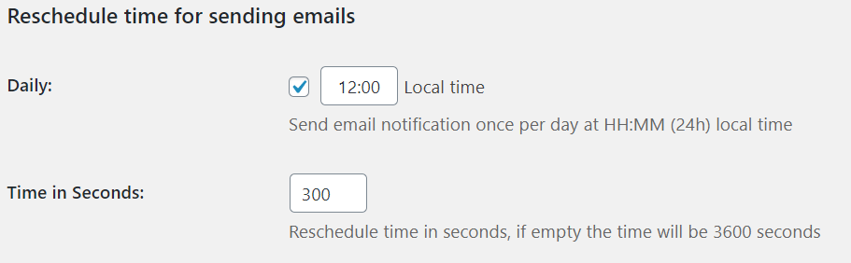

Figure 34 E-mail notification analysis on Daily basis (12:00)

## Resend post on update

STC looks for new or updates post of post type ‘post’. Via the STC Settings interface it is possible to choose receive e-mails on new or new & updated posts.

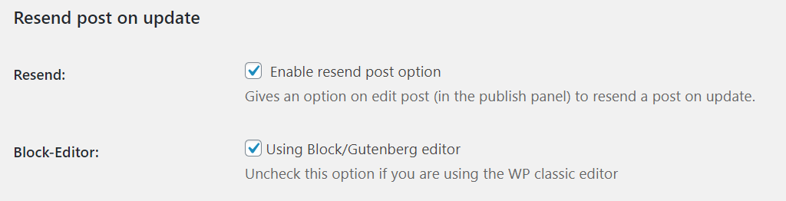

Figure STC Settings for editor and post updates

The figure above shows that with the Resend checkbox checked new & updates post are observed by STC. Depending on the WordPress Editor in use (Classic or Block) STC interfaces differently to control the update initiative. Note the possibility to prevent STC to send updates by ticking the checkbox "Do not mail this blog".

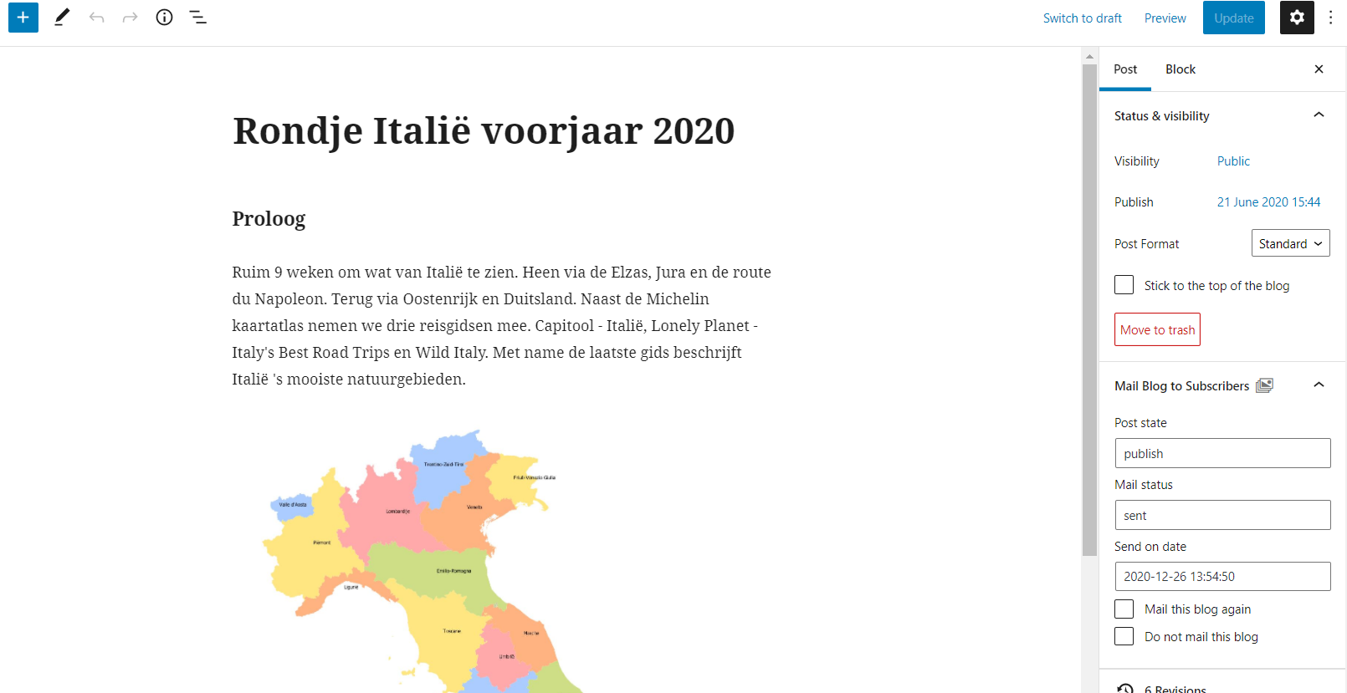

Figure 35 In the red box the block editor STC update interface

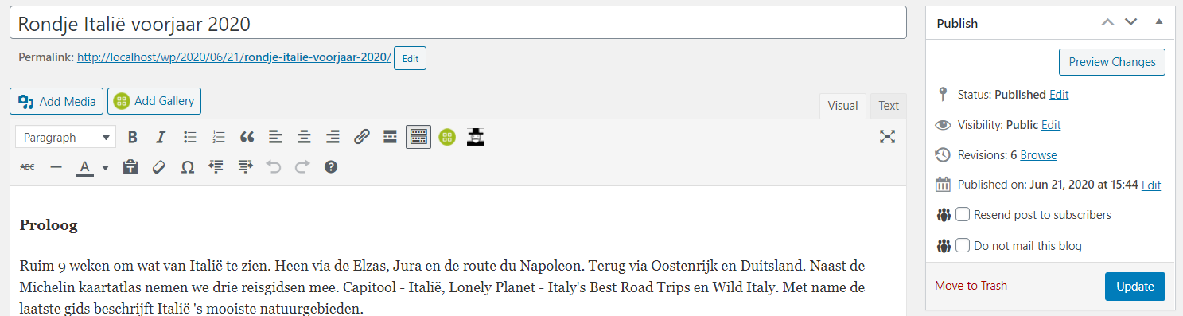

Figure 36 In the red box the classic editor STC update interface

When STC is activated new posts are always and updated post only when checked (in the red boxes) are analyzed by STC if the post meets the subscription criteria.

## Stylesheet Settings

Check this option if you want to use your own CSS for Subscribe to Category

## On plugin deactivation

Checking this option will ensure that all data regarding subscribers is removed when the plugin is deactivated.

# STC Core functionality

MySQL wp_database

User  
Creates a new post

User  
Interaction

Hook / outbox

Posts

posts, subscribers E-mails

Posts E-mails

Selected Post Types

Post and Meta data

Cron timer fires

# Timer Jobs in WordPress

WP-Cron is how WordPress handles scheduling time-based tasks in WordPress. Several WordPress core features, such as checking for updates and publishing scheduled post, utilize WP-Cron. The "Cron" part of the name comes from the Cron time-based task scheduling system that is available on UNIX systems.

WP-Cron works by checking, on every page load, a list of scheduled tasks to see what needs to be run. Any tasks due to run will be called during that page load. Basically, this means that on websites with only a view page loads per day it can take a long time before STC checks if e-mail notifications are to be send to subscribers.

When it is vital that certain actions are executed asap there is a problem. Luckily, there are two solutions to overcome this problem.

* Some website providers have a facility to send your website a external page load trigger and you can setup this trigger with the tools of these providers.
* Or make use of a free website like <http://cron-job.org> to setup a Cronjob to trigger a page load. In the figure below a Cronjob is setup to trigger the website [www.vandestouwe.com](http://www.vandestouwe.com)

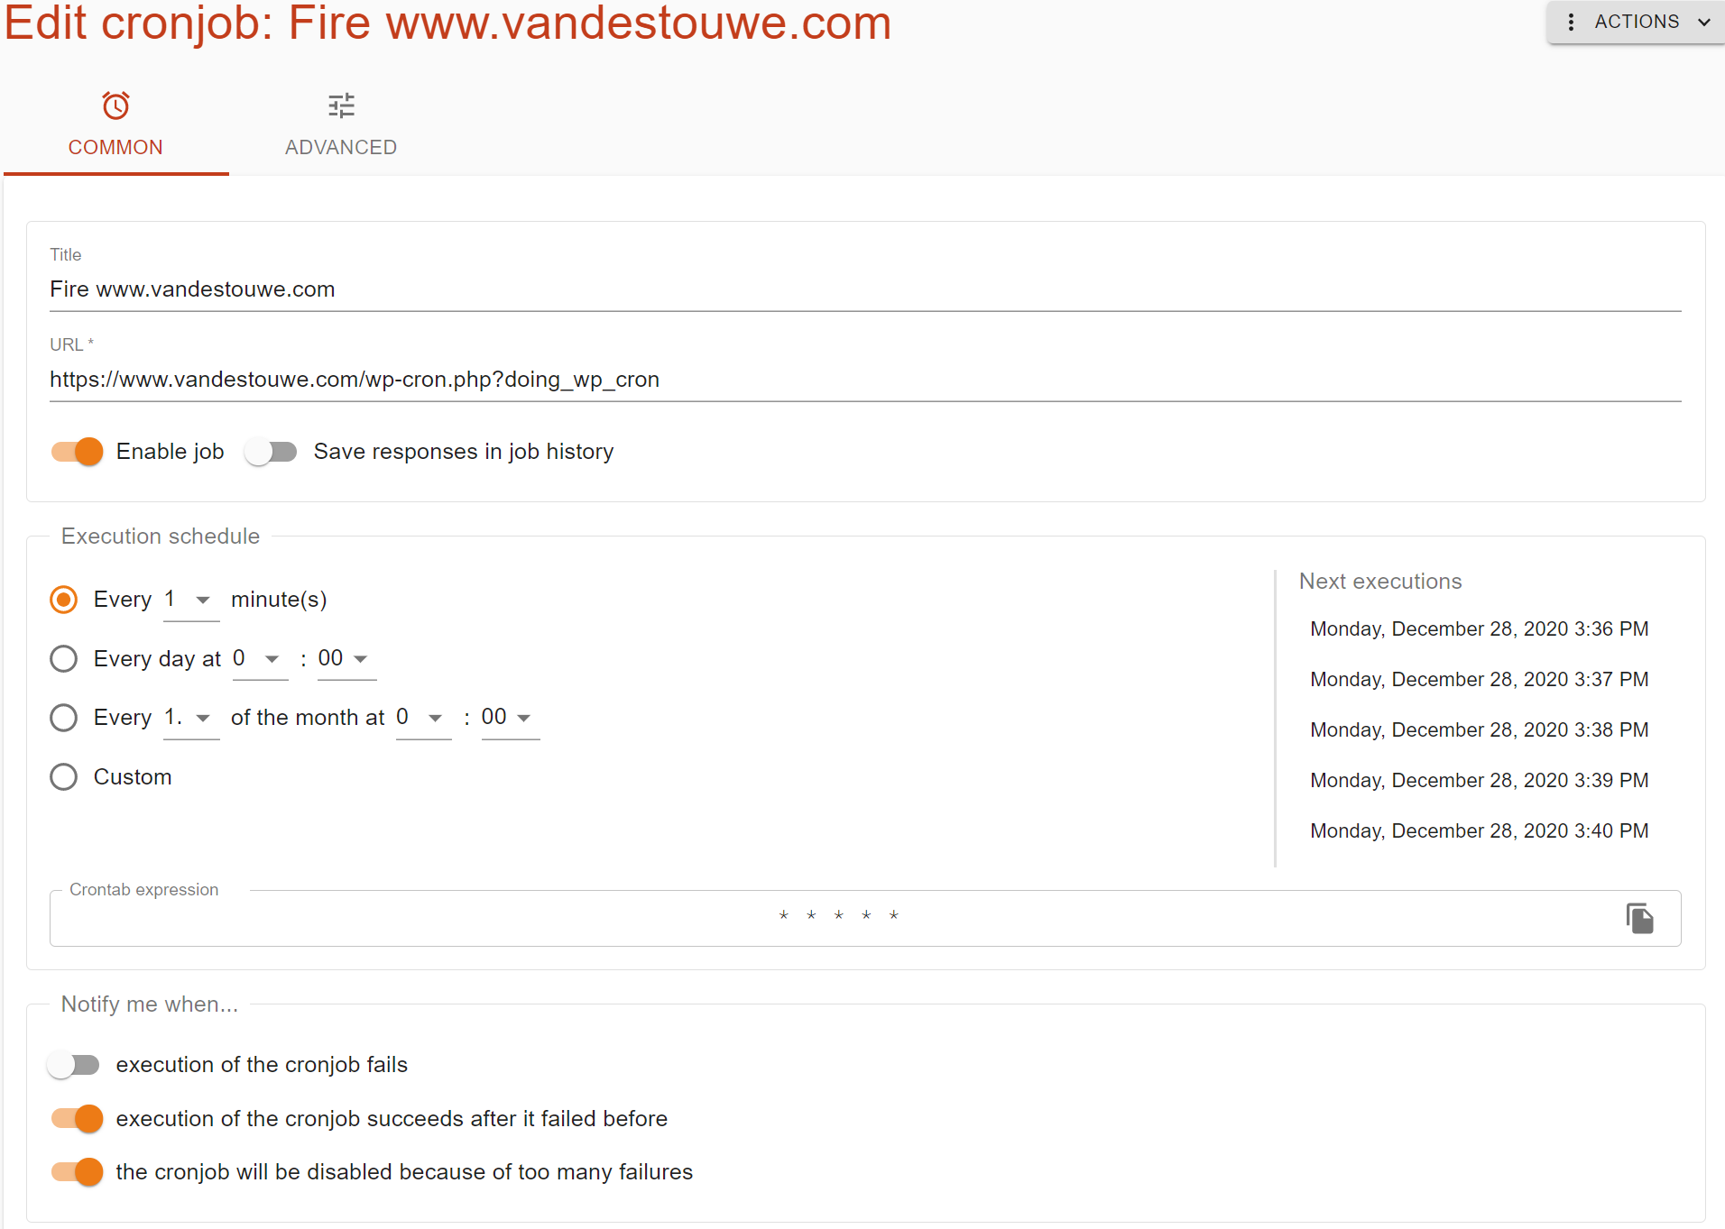

Figure 37 Setting up an external Cronjob at cronjob.org

* In both solutions, you need to disable the script to be executed every time someone loads one of your pages. To do this, open the wp-config.php file in your main WordPress folder and add the following line before the   
  "/* That’s all, stop editing! Happy blogging. */" line:define('DISABLE_WP_CRON', true);

1. The STC Setting: enable keyword search must also be checked
2. The STC Setting: hide unsubscribe must also be checked
3. The STC Setting: enable keyword search must also be checked